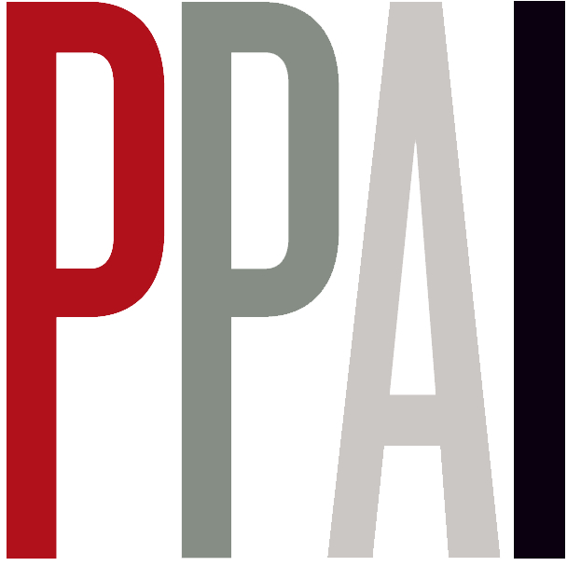
Press Release 31 December 2007

Irish magazines advertising revenue up to a huge €239 million

New figures for advertising spend in Irish magazines show magazines received a huge
€239 million in advertising revenue putting it in third place, behind only national press and television, and ahead of regional press, outdoor, radio, cinema and the internet.

The Periodical Publishers’ Association of Ireland (PPAI) has expressed its satisfaction with the results of this up-to-date survey conducted on advertising revenue in magazines, carried out by Breakdown of Advertising Share and Expenditure (BASE) at the Institute of Advertising Practitioners in Ireland (IAPI).

The Magazine Advertising Revenue Survey is the third comprehensive survey conducted on advertising in magazines in Ireland, and it provides an in-depth analysis of advertising revenue and volume. This groundbreaking piece of research covers 320 Irish-published magazines.

This new research correctly values the magazine share of the Irish advertising market for 2007. The relative values show that the advertising spend in Irish magazines accounts for 12% of the total value of Irish advertising, and this compares favourably with international values at similar levels.

Medium €millions %

National Press 792 41
TV 394 19

Magazines 239 12
Regional Press 212 11
Outdoor 146 8
Radio 140 7
Internet 22 1
Cinema 12 1

“The results of this year’s survey show an increase of 10% in advertising revenue in magazines compared with the previous year. It is another endorsement of the effectiveness and efficiency of the Irish magazine industry to reach core target audiences. The industry publishes 320 titles covering the full range of demographics and interest groups in Irish society”, said Richard Power, Chairman, PPA Ireland.
For further information please contact Grace Aungier 01 667 55 79

